COLLEGE OF COMPUTER STUDIES AND MULTIMEDIA ARTS

CCS0006L
(COMPUTER PROGRAMMING 1)

EXERCISE
5

CONDITIONAL CONTROL STRUCTURES

Student Name / Group Name: | Jham Justin C. Catacutan
Members (if Group):
  Name | Role
Section: | BSITWMA – TW01
Professor: | Mr. Ronel Ramos

- PROGRAM OUTCOME/S (PO) ADDRESSED BY THE LABORATORY EXERCISE
- Analyze a complex problem and identify and define the computing requirements appropriate to its solution. [PO: B]
- Design, implement and evaluate computer-based systems or applications to meet desired needs and requirements. [PO: C]
- COURSE LEARNING OUTCOME/S (CLO) ADDRESSED BY THE LABORATORY EXERCISE
- Select and apply appropriate program constructs in developing computer programs. [CLO: 2]
- Develop, test and debug computer programs based on a given specification using the fundamental programming components. [CLO: 3]

- INTENDED LEARNING OUTCOME/S (ILO) OF THE LABORATORY EXERCISE
At the end of this exercise, students must be able to:
  - Know the importance of each type of conditional control structures and how to implement it in a C++ program.
  - Write C++ programs that use different conditional control structures to solve problems.

- BACKGROUND INFORMATION

Conditional control statements are at the very core of programming, in almost any language. The idea behind conditional control is that it allows you to control the flow of the code that is executed based on different conditions in the program, input taken from the user, the internal state of the machine the program is running on, etc.

Conditional statements specify whether another statement or block of statements should be executed or not. These are often called "selection constructs". A conditional expression is an expression that produces a true or false result. There are three major structures related to the conditional execution of code in C/C++ - the if statement, the if-else statement, and the switch-case statement.

- if-statement

Syntax:
if(condition_expression)
statement;

Where condition is the expression that is being evaluated. If this condition is true, statement is executed. If it is false, statement is ignored (not executed) and the program continues right after this conditional structure.

Example:

if (x == 0)
System.out.println(“The no. is zero.”);

- if-else statement

Syntax:

if(Condition_Expression)
Statement_TRUE;
else
Statement_FALSE;

If the if statement evaluates to true, then all the statements inside the if block are executed and the else if will be ignored. When the if statement is false, it will then check the condition in the else if statement.

Example No. 1

if (x >= 0)
System.out.println(“The no. is a whole number.”);
else
System.out.println(“The no. is a negative number.”);

Example No. 2

if (x %2 == 0)
JOptionPane.showMessageDialog(“It is EVEN.”);
else
JOptionPane.showMessageDialog(“It is ODD.”);

- if-ladder statement

Syntax:

if(Condition_Expression1)
Statement1;
else if(Condition_Expression2)
Statement2;
else if(Condition_Expression3)
Statement3;
else
Statement-n;

Reminders:
- condition_expression contains the test expression. If the test expression evaluates to true (ie. non-zero), StatementBlock is executed, otherwise the ElseStatementBlock is executed.
- If there is more than one statement to be executed within the ThenStatementBlock or ElseStatementBlock branch, the blocks must be enclosed with {}'s.
- It is not necessary to have an else statement within each if() conditional.
- Multiple expressions can be evaluated by using conjunctions (e.g. &&, ||).
- Indent your programs to increase readability.
- Do not confuse the uses of assignment (=) and equality (==) operators, especially within the test condition. They can have adverse effects on your program.

- switch statement
The syntax of the switch statement is:

switch(expression) {
case constant_value_1: statement1;
break;
case constant_value_2: statement2;
break;
case constant_value_3: statement3;
break;
case constant_value_n: statement_n;
break;
default: statement_default;
}

When defining an expression whose result would lead to a specific program execution, the switch statement considers that result and executes a statement based on the possible outcome of that expression, this possible outcome is called a case.
The different outcomes are listed in the body of the switch statement and each case has its own execution, if necessary. The body of a switch statement is delimited from an opening to a closing curly brackets: “{“ to “}”.

- LABORATORY ACTIVITY

ACTIVITY 5.1: Whatta Grade!!!

Get three exam grades from the user and compute the average of the grades. Output the average of the three exams. Together with the average, also include a smiley face in the output if the average is greater than or equal to 70, otherwise output :-(. Note: Use if-statement in the program.

Program: (save as [surname_5_1.cpp])
/******************************************************************************

Jham Justin C. Catacutan
BSIT- WMA TW01

*******************************************************************************/
#include <iostream>
using namespace std;

int main(){
int g1,g2,g3,average;
cout<< "Enter your first Grade: ";
cin >> g1;
cout << "Enter your second grade: ";
cin >> g2;
cout << "Enter your Third grade: " ;
cin >> g3;
average = (g1+g2+g3)/3;
if (average >= 70 )
cout<< "Your average is " <<average<< endl << " Congrats :)";
else
cout<< "Your average is " << average << endl << "Aral pang Mabuti! :-(";

}

Output:(screenshot of the output)
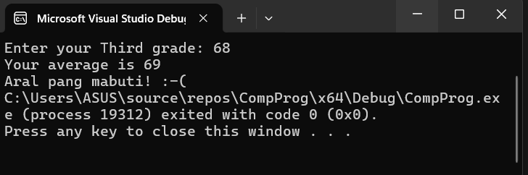

ACTIVITY 5.2: What is your horoscope?

Write a C++ program that will read in month and day (as numerical value). The program will return the equivalent zodiac sign.

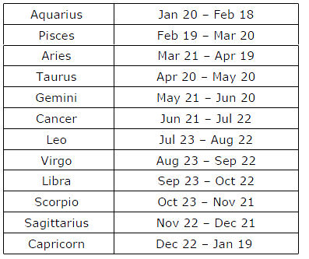

Sample output:
Enter month: 6
Enter day: 25
Zodiac sign for June 25 is Cancer

Activity 5.2a What is your horoscope? (Using if-statement)

Program: (save as [surname_5_2a.cpp])
/**************************************************************************
Jham Justin C. Catacutan
BSIT - WMA TW01
***************************************************************************/
#include <iostream>
using namespace std;

int main() {
int month, day;
cout << "Enter month: ";
cin >> month;
cout << "Enter day: ";
cin >> day;
string zodiac, monthname;
if (month == 1) monthname = "January";
else if (month == 2) monthname = "February";
else if (month == 3) monthname = "March";
else if (month == 4) monthname = "April";
else if (month == 5) monthname = "May";
else if (month == 6) monthname = "June";
else if (month == 7) monthname = "July";
else if (month == 8) monthname = "August";
else if (month == 9) monthname = "September";
else if (month == 10) monthname = "October";
else if (month == 11) monthname = "November";
else if (month == 12) monthname = "December";
else monthname = "Invalid";
if ((month == 1 && day >= 20) || (month == 2 && day <= 18))
zodiac = "Aquarius";
else if ((month == 2 && day >= 19) || (month == 3 && day <= 20))
zodiac = "Pisces";
else if ((month == 3 && day >= 21) || (month == 4 && day <= 19))
zodiac = "Aries";
else if ((month == 4 && day >= 20) || (month == 5 && day <= 20))
zodiac = "Taurus";
else if ((month == 5 && day >= 21) || (month == 6 && day <= 20))
zodiac = "Gemini";
else if ((month == 6 && day >= 21) || (month == 7 && day <= 22))
zodiac = "Cancer";
else if ((month == 7 && day >= 23) || (month == 8 && day <= 22))
zodiac = "Leo";
else if ((month == 8 && day >= 23) || (month == 9 && day <= 22))
zodiac = "Virgo";
else if ((month == 9 && day >= 23) || (month == 10 && day <= 22))
zodiac = "Libra";
else if ((month == 10 && day >= 23) || (month == 11 && day <= 21))
zodiac = "Scorpio";
else if ((month == 11 && day >= 22) || (month == 12 && day <= 21))
zodiac = "Sagittarius";
else if ((month == 12 && day >= 22) || (month == 1 && day <= 19))
zodiac = "Capricorn";
else
zodiac = "Invalid date";
cout << "Zodiac sign for " << monthname << " " << day << " is " << zodiac << endl;
return 0;
}

Output:(screenshot of the output)
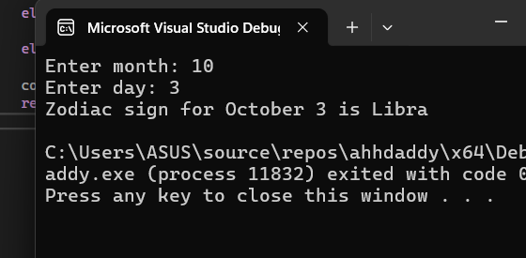

Activity 5.2b What is your horoscope? (Using switch statement)

Program: (save as [surname_5_2b.cpp])
/******************************************************************************
Catacutan, Jham Justin C.
*******************************************************************************/
#include <iostream>
using namespace std;

int main()
{
int month, day;
cout << "Enter month (1-12): ";
cin >> month;
cout << "Enter day: ";
cin >> day;

string zodiac;

// Determine zodiac sign
if ((month == 1 && day >= 20) || (month == 2 && day <= 18))
zodiac = "Aquarius";
else if ((month == 2 && day >= 19) || (month == 3 && day <= 20))
zodiac = "Pisces";
else if ((month == 3 && day >= 21) || (month == 4 && day <= 19))
zodiac = "Aries";
else if ((month == 4 && day >= 20) || (month == 5 && day <= 20))
zodiac = "Taurus";
else if ((month == 5 && day >= 21) || (month == 6 && day <= 20))
zodiac = "Gemini";
else if ((month == 6 && day >= 21) || (month == 7 && day <= 22))
zodiac = "Cancer";
else if ((month == 7 && day >= 23) || (month == 8 && day <= 22))
zodiac = "Leo";
else if ((month == 8 && day >= 23) || (month == 9 && day <= 22))
zodiac = "Virgo";
else if ((month == 9 && day >= 23) || (month == 10 && day <= 22))
zodiac = "Libra";
else if ((month == 10 && day >= 23) || (month == 11 && day <= 21))
zodiac = "Scorpio";
else if ((month == 11 && day >= 22) || (month == 12 && day <= 21))
zodiac = "Sagittarius";
else if ((month == 12 && day >= 22) || (month == 1 && day <= 19))
zodiac = "Capricorn";
else {
cout << "Invalid date entered." << endl;
return 0; // stop program here
}

// Convert month number to month name
string monthname;
switch (month) {
case 1: monthname = "January"; break;
case 2: monthname = "February"; break;
case 3: monthname = "March"; break;
case 4: monthname = "April"; break;
case 5: monthname = "May"; break;
case 6: monthname = "June"; break;
case 7: monthname = "July"; break;
case 8: monthname = "August"; break;
case 9: monthname = "September"; break;
case 10: monthname = "October"; break;
case 11: monthname = "November"; break;
case 12: monthname = "December"; break;
default:
cout << "Invalid month entered." << endl;
return 0;
}

cout << "Your zodiac for " << monthname << " " << day << " is " << zodiac << "." << endl;

return 0;
}

Output:(screenshot of the output)

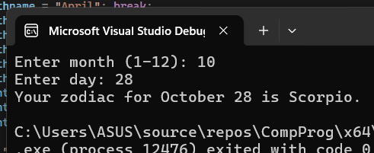

ACTIVITY 5.3: Monthly Sales

Using if-ladder statements, compute for the income given the monthly sales. Refer to the table below for the range.

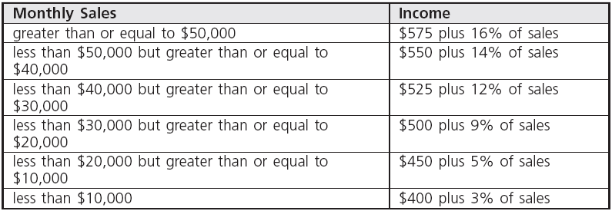

Program: (save as [surname_5_3.cpp])

/***************************************************************
Jham Justin C. Catacutan
BSIT - WMA TW01
***************************************************************/

#include <iostream>
using namespace std;

int main() {
double Sales, Income;
cout << "Enter monthly sales: ";
cin >> Sales;
if (Sales >= 50000) {
Sales = 575 + (0.16 * Sales);
}
else if (Sales >= 40000) {
Sales = 550 + (0.14 * Sales);
}
else if (Sales >= 30000) {
Sales = 525 + (0.12 * Sales);
}
else if (Sales >= 20000) {
Sales = 500 + (0.09 * Sales);
}
else if (Sales >= 10000) {
Sales = 450 + (0.05 * Sales);
}
else {
Sales = 400 + (0.03 * Sales);
}
cout << "The income is: $" << Sales << endl;
return 0;
}

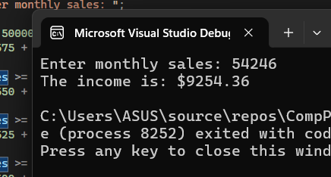
Output:(screenshot of the output)

ACTIVITY 5.4: Volume of Figures

Using switch statement, write a program that will ask the user which figure he/she wants to solve. The user should accept lowercase or uppercase as input to the option chosen by the user.

Sample Output:

Volume of Figures
[C] – Cube
[R] – Rectangular Prism
[S] – Sphere
Choose figure: C

You have chosen Cube.
Enter side: 3
The volume of the cube is: 27

Program: (save as [surname_5_4.cpp])

/**************************************************************************
Jham Justin C. Catacutan
BSIT - WMA TW01
***************************************************************************/
#include <iostream>
#include <cmath>
using namespace std;
#define PI 3.1415926

int main() {
char choice;
cout << "Volume of Figures\n";
cout << "[C] - Cube\n";
cout << "[R] - Rectangular Prism\n";
cout << "[S] - Sphere\n";
cout << "\nChoose figure: ";
cin >> choice;

double volume;

switch (choice) {
case 'C':
case 'c': {
double side;
cout << "\nYou have chosen Cube.\n";
cout << "Enter side: ";
cin >> side;
volume = pow(side, 3);
cout << "The volume of the cube is: " << volume << endl;
break;
}
case 'R':
case 'r': {
double length, width, height;
cout << "\nYou have chosen Rectangular Prism.\n";
cout << "Enter length: ";
cin >> length;
cout << "Enter width: ";
cin >> width;
cout << "Enter height: ";
cin >> height;
volume = length * width * height;
cout << "The volume of the rectangular prism is: " << volume << endl;
break;
}
case 'S':
case 's': {
double radius;
cout << "\nYou have chosen Sphere.\n";
cout << "Enter radius: ";
cin >> radius;
volume = (4.0 / 3.0) * PI * pow(radius, 3);
cout << "The volume of the sphere is: " << volume << endl;
break;
}
default:
cout << "\nInvalid choice. Please choose C, R, or S." << endl;
}

return 0;
}

Output:(screenshot of the output)

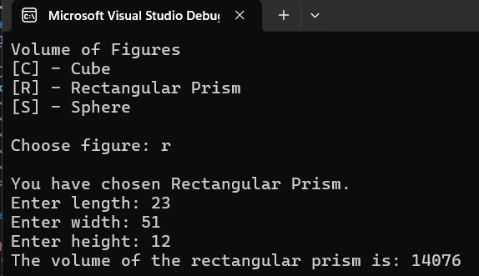

- QUESTION AND ANSWER

Directions: Briefly answer the questions below.

  - For you, which is preferably the most convenient control structure to be used in comparisons, IF-ELSE or SWITCH?

• For me, the most convenient control structure to use in comparisons is the if-else statement.
I think it’s easier to understand and use, especially when there are only a few conditions to check. It’s also more flexible because you can compare different types of values or use more complex conditions. The switch statement is also good, but it only works well when you’re comparing one variable to fixed values. So overall, I prefer if-else because it’s simpler and can handle more kinds of comparisons.
  - What do you think is the importance of having different if structures such as if statement, if-else statement and nested-if statement?

• I think having different types of if structures like if, if-else, and nested-if is important
because they let us control how our program reacts to different situations. The basic if is used when we only need to check one condition. The if-else helps when there are two possible outcomes. The nested-if is useful when we need to check multiple conditions step by step. Having these different structures makes our code more organized, clear, and able to handle different cases properly.

- REFERENCES
- Abraham (2015). Coding for dummies. John Wiley and Sons: Hoboken, NJ
- Zak, D (2015). An Introduction to Programming with C++. 8th Edition
- Cadenhead, R et. Al. (2016). C++ in 24 Hours, Sams Teach Yourself (6th Edition).Sams Publishing
- McGrath, M. (2017). C++ programming in easy steps (5th ed.). Warwickshire, United Kingdom: Easy Steps Limited
- Tale, T. (2016). C++: The Ultimate Beginners Guide to C++ Programing. CreateSpace Independent Publishing Platform
- http://cs.uno.edu/~jaime/Courses/2025/devCpp2025Instructions.html

RUBRIC:
Criteria | 4 | 3 | 2 | 1 | Score
Solution(x5) | A completed solution runs without errors. It meets all the specifications and works for all test data. | A completed solution is tested and runs but does not meet all the specifications nd/or work for all test data. | A completed solution is implemented on the required platform, and uses the compiler  specified. It runs, but has logical errors. | An incomplete solution is implemented on the required platform. It does not compile and/or run.
Program Design(x3) | The program design uses appropriate structures. The overall program design is appropriate. | The program design generally uses appropriate structures. Program elements exhibit good design. | Not all of the selected structures are appropriate. Some of the program elements are appropriately designed. | Few of the selected structures are appropriate. Program elements are not well designed.
Completeness of Document(x2) | All required parts of the document are complete and correct(code, output of screenshots) | All required parts in the document are present and correct but not complete. | There are few parts of the document are missing but the rest are complete and correct. | Most of the parts of the document are missing and incorrect.
 |  |  |  |  | Total

